**19CSE435 – COMPUTER VISION**



**GROUP-10. ANOMALY DETECTION IN COLLEGE ENVIRONMENT**

**Member Detail:**

|  |  |  |
| --- | --- | --- |
| **ROLL NUMBER** | **NAME** | **Contribution** |
| CB.EN.U4CSE21024 | ANALA JAHNAVI | Literature survey, Tracking, Feature detection (OLB), Corner Detection, Optical Flow algorithm (DenseNet Optical Flow), SVM, Documentation. |
| CB.EN.U4CSE21034 | MANTHINI MEHER VARDHAN | Dataset Generation, Literature survey, initial preprocessing techniques, Feature detection (Harris corner), Edge detection, Optical Flow algorithm (PyrLK Optical Flow), PPT. |
| CB.EN.U4CSE21040 | NERELLA GEETHA KRISHNA | Matching, Literature survey, Optical Flow Algorithm (Farneback Optical Flow), Dataset Alignment, Image Processing Techniques, Feature detection (GOLF), Filters, Testing, PPT. |
| CB.EN.U4CSE21062 | TANGUDU HARSHA VARDHAN | Feature detection (SIFT), Literature survey, Preprocessing, Projection methods and colour spaces, CNN models Training, Optical Flow algorithm (Lucas-Kanade Optical Flow), Documentation. |

**PART-A**

**A. Problem statement:**

College’s face ongoing difficulties in maintaining safety, order, property integrity, health standards, and college policy. While Anomaly detection systems offer promise in addressing these issues, there's a need for a clear plan to effectively implement these systems.

This plan should prioritize the safety and well-being of everyone on campus while also supporting an environment conducive to learning.

In this project, we will utilize multiple images and videos captured in various scenarios involving smoking, drinking, fighting, reckless driving, exam cheating, hanging out of moving buses, chasing after buses, engaging in ragging, shouting, disrupting the college environment, vandalism, and other related activities.

In addition, we will develop a system that concurrently provides solutions when detecting the aforementioned scenarios.

**Broad Objective:**

The overarching goal is to create a comprehensive anomaly detection system that actively enhances the safety, security, and overall well-being of everyone on a college campus. This system will leverage machine learning and computer vision techniques to automatically identify and address situations that deviate from normal campus behavior.

**Specific Objectives:**

1. **Highly Accurate Anomaly Detection:**
   * Train the system on a vast dataset of images and videos encompassing a wide range of normal and abnormal campus activities. This includes smoking in unauthorized areas, underage drinking, physical altercations, reckless driving on campus grounds, exam cheating attempts (e.g., copying answers, using unauthorized materials), students hanging dangerously off moving buses, chasing after moving buses in a risky manner, ragging (harassment) incidents, shouting that disrupts classes or study areas, vandalism of property, and other related activities.
   * Utilize advanced image recognition and object detection algorithms to achieve high accuracy in identifying these anomalies within captured images and video feeds.
2. **Prioritized Safety Response:**
   * Develop a tiered response system based on the severity of the detected anomaly. Situations like physical fights or vandalism will be flagged as critical, triggering immediate alerts to campus security personnel.
   * For less critical situations (e.g., smoking, shouting), the system can provide warnings or notifications to relevant authorities for further investigation.
3. **Promoting a Positive Learning Environment:**
   * Train the system to identify behaviors that disrupt the learning environment, such as excessive noise levels in study areas or students exhibiting signs of cheating during exams.
   * Upon detection, the system can trigger automated messages reminding students of campus policies or discreetly notify proctors/supervisors for intervention.
4. **Real-Time Solutions and Automated Responses:**
   * Design the system to operate in real-time, analyzing incoming image and video data with minimal delay. This allows for immediate detection and response to unfolding situations.
   * Develop the system to suggest or initiate automated actions based on the detected anomaly. This may involve sending alerts to security personnel, displaying warnings on nearby digital signage, or activating surveillance cameras to capture a clearer picture of the situation.

By achieving these specific objectives, the anomaly detection system will become a valuable tool for promoting a safer, more secure, and focused learning environment for all college students, faculty, and staff.

|  |  |  |
| --- | --- | --- |
| **Objective** | **Key Question** | **Potential Solutions** |
| **Detect Smoking and Drinking on Campus** | How can the system accurately identify instances of smoking and drinking in various campus locations? | Collect diverse images/videos of smoking/drinking.  Train CNN models for identification.  Implement real-time CCTV monitoring.  Set up automatic alerts to security. |
| **Prevent and Mitigate Fighting and Disruptive Behavior** | How can the system differentiate between normal student interactions and potential fights or disruptive behaviors? | Train models to recognize aggressive behaviors.  Use unsupervised algorithms for anomaly detection.  Develop protocols for automatic escalation to security. |
| **Detect and Prevent Exam Cheating** | How can the system reliably detect cheating during exams without invading student privacy? | Develop models to identify suspicious behaviors.  Use non-invasive monitoring techniques.  Notify exam proctors of potential cheating. |
| **Identify and Address Reckless Driving and Dangerous Bus Behavior** | What methods can be employed to detect reckless driving and dangerous behaviors related to buses on campus? | Monitor vehicle speeds using video analytics.  Detect students hanging out or chasing buses.  Create incident reporting mechanisms. |
| **Monitor and Control Ragging Activities** | How can the system help identify and mitigate ragging incidents on campus? | Train models to detect ragging behaviors.  Record and log potential incidents for investigation.  Integrate support resources for victims. |
| **Address Vandalism and Property Damage** | What strategies can be used to detect and prevent vandalism on campus? | Use object recognition for detecting vandalism.  Analyze historical data to identify vandalism hotspots.  Increase surveillance in identified hotspots. |
| **Ensure General Campus Safety and Order** | How can the system ensure overall safety and order across the campus? | Deploy a comprehensive network of cameras.  Integrate the system with existing security infrastructure.  Regularly update and maintain the system. |
| **Create a Conducive Learning Environment** | How can the system support an environment conducive to learning while ensuring safety and order? | Balance surveillance measures with privacy.  Educate students on the system’s purpose and benefits.  Establish a feedback mechanism for concerns and suggestions. |

**B. DATASET DETAIL:**

[**https://drive.google.com/drive/folders/1vdsMuTLC2OxboYeuE5oZ45UsZKYsG-EM**](https://drive.google.com/drive/folders/1vdsMuTLC2OxboYeuE5oZ45UsZKYsG-EM)

**KAGGLE DATASET:**

These datasets include videos in .mp4 format, there are many scenarios showing about untrimmed real-world surveillance videos, with 13 realistic anomalies including Abuse, Arrest, Arson, Assault, Road Accident, Burglary, Explosion, Fighting, Robbery, Shooting, Stealing, Shoplifting, and Vandalism.

|  |  |  |  |  |  |  |
| --- | --- | --- | --- | --- | --- | --- |
| S.no | Dataset name | No. of Files | Resolution | Environment | Color | Image/ Video Format |
| 1 | [Anomaly-Detection-Dataset-UCF](https://www.kaggle.com/datasets/minhajuddinmeraj/anomalydetectiondatasetucf?resource=download) | 8369 | 320*240 | Indoor and Outdoor | All Colors | .mp4 |

**CUSTOM DATSET:**

This dataset consists of Images of 60 in .jpg format and Videos of 200 in .mp4 format in below mentioned Drive link.

This dataset is purely collected from our college environment which consist of maximum anomaly behaviors of students.

As we planned for this phase update - collected only anomaly consisting Dataset.

|  |  |  |  |  |  |  |
| --- | --- | --- | --- | --- | --- | --- |
| S.no | Dataset name | No. of Files | Resolution | Environment | Color | Image/ Video Format |
| 1 | [Anomaly detection in college environment](https://drive.google.com/drive/folders/1vdsMuTLC2OxboYeuE5oZ45UsZKYsG-EM) | 260 | Multiple Resolutions | Indoor and Outdoor | All Colors | .mp4 & .jpg |

|  |  |  |  |  |
| --- | --- | --- | --- | --- |
| Camera  Front 16MP / Rear 64MP+2MP+2MP  Aperture  Front f/2.0(16MP), Rear f/1.79(64MP) + f/2.4 (2MP) + f/2.4 (2MP)  Flash  Rear flash  Scene Mode  Night (front & rear), Portrait, Photo, Video, Pano, Live Photo, Slo-Mo, Time-Lapse, Pro, DOC, AI 64MP | Ultra wide  50 MP  Samsung JN1 sensor  ƒ/2.2 aperture  1/2.76” sensor size  EIS image stabilisation  114° field of view  Night Mode  Macro (4 cm)  HDR | Front Camera  16 MP  Sony IMX471 sensor  ƒ/2.45 aperture  1/3.1” sensor size  Live Photo  HD Portrait  Google Filter  Beauty Mode  Night Mode  1080p video recording at 30 fps | Video  4K recording at 30 fps  1080p recording at 30 or 60 fps  Live HDR at 30 fps  Slo-mo (120 fps)  Night Mode (720p/1080p at 30 fps)  OIS and EIS image stabilisation | Main Camera  50 MP  Sony IMX766 sensor  ƒ/1.88 aperture  1/1.56” sensor size  1 µm pixel size  Focal length: 24 mm |

**DATA COLLECTION METHODS:**

**1. Test Setup:**

- Design a controlled environment representative of typical campus scenarios.

- Install cameras strategically to cover Key areas like corridors, lecture halls, and outdoor spaces.

- Ensure proper lighting conditions to avoid shadows or glare that could affect image quality.

- Set up multiple camera angles to capture diverse perspectives of activities.

**2. Calibration Process:**

- Align cameras to ensure consistency in image orientation and resolution.

- Adjust camera settings such as focus, exposure, and white balance for optimal performance.

- Use calibration objects or markers to calibrate camera intrinsic and extrinsic parameters.

- Validate calibration accuracy through geometric and photometric calibration techniques.

**3. Testing Phase:**

- Conduct controlled scenarios to simulate various anomalies like smoking, fighting, or vandalism.

- Record videos and capture images of these scenarios using calibrated cameras.

- Vary environmental factors such as lighting conditions, crowd density, and weather to diversify the dataset.

- Ensure ethical considerations by obtaining consent for recording from participants or anonymizing data as needed.

**4. Heatmap Generation:**

- Analyze collected data to generate heatmaps indicating the frequency and intensity of detected anomalies.

- Utilize computer vision algorithms to process images and videos, detecting and classifying anomalies.

- Aggregate detection results over time to identify hotspots of activity.

- Visualize heatmap data overlaid on campus maps or surveillance footage for intuitive interpretation.

**5. Participant Details:**

- Document demographic information of participants involved in simulated scenarios.

- Record relevant attributes such as age, gender, and role (e.g., student, faculty, staff).

- Maintain anonymity or pseudonymity where necessary to protect privacy.

- Obtain consent forms or waivers from participants outlining the purpose and scope of data collection.

**DATA PREPROCESSING METHODS:**

Certainly! Here's a brief description of each preprocessing method along with Key steps involved and detailed analysis:

**1. Corner Detection - Shi-Tomasi Corner Detection:**

Key Steps:

- Compute the gradient of the image using Sobel operators.

- Calculate the structure tensor for each pixel.

- Compute the corner response function using eigenvalues of the structure tensor.

- Select corners based on the corner response function threshold.

Detailed Analysis

- Shi-Tomasi Corner Detection algorithm is a variant of Harris Corner Detection.

- It selects corners based on the minimum eigenvalue of the structure tensor, which represents the smallest variation in intensity.

- It provides more stable and reliable results compared to Harris Corner Detection, especially in the presence of noise.

**2. Edge Detection - Canny Edge Detection and Laplacian of Gaussian:**

Key Steps (Canny Edge Detection):

- Smooth the image using Gaussian filter to reduce noise.

- Compute gradients using Sobel operators to find intensity changes.

- Apply non-maximum suppression to thin edges.

- Perform hysteresis thresholding to detect strong and weak edges.

Detailed Analysis:

- Canny Edge Detection is a multi-stage algorithm known for its accuracy and robustness.

- It effectively detects edges while suppressing noise and reducing false positives.

Key Steps (Laplacian of Gaussian):

- Convolve the image with a Gaussian kernel to smooth it.

- Compute the Laplacian operator to highlight regions of rapid intensity change.

- Threshold the result to obtain edges.

Detailed Analysis:

- Laplacian of Gaussian combines Gaussian smoothing and edge detection into a single step.

- It highlights edges by detecting zero-crossings in the second derivative of the image.

**3. Filters - Anisotropic Diffusion:**

Key Steps:

- Define a diffusion function to control the rate of diffusion.

- Apply iterative diffusion to smooth the image while preserving edges.

Detailed Analysis:

- Anisotropic Diffusion is a nonlinear filtering technique used for edge-preserving smoothing.

- It diffuses information across homogeneous regions while preserving edges, making it suitable for denoising images without blurring edges.

**4. Projection Methods - Perspective Projection:**

Key Steps:

- Define the intrinsic parameters of the camera (e.g., focal length, principal point).

- Estimate the extrinsic parameters (e.g., camera position and orientation) relative to the scene.

- Apply perspective transformation to project 3D scene onto a 2D image plane.

Detailed Analysis:

- Perspective Projection is crucial for transforming the 3D world into 2D images, maintaining spatial relationships and depth perception.

- It enables accurate geometric transformations necessary for tasks like object detection, localization, and scene understanding.

**5. Colour Spaces - HSV and LAB:**

Key Steps:

- Convert RGB image to HSV or LAB color space.

- Analyze color channels separately for hue, saturation, and value (HSV) or lightness, green-red, and blue-yellow (LAB).

- Utilize specific channels for targeted analysis or feature extraction.

Detailed Analysis:

- HSV and LAB color spaces offer advantages over RGB for various computer vision tasks.

- HSV separates color information from intensity, making it suitable for tasks involving color detection or segmentation.

- LAB is perceptually uniform and can better represent color differences, making it useful for color-based image processing tasks.

**6. Histogram Equalization:**

Key Steps:

- Calculate the histogram of the image to analyze intensity distribution.

- Compute the cumulative distribution function (CDF) of the histogram.

- Transform the intensity values of the image using the CDF to achieve a more uniform histogram.

Detailed Analysis:

- Histogram Equalization enhances the contrast of an image by redistributing intensity values.

- It stretches the intensity range of an image, making it more visually appealing and improving feature visibility.

- However, it may amplify noise in regions with low contrast, so caution is needed in its application.

These preprocessing methods play crucial roles in enhancing image quality, extracting relevant features, and preparing data for subsequent analysis and interpretation in our tasks.

**Usage of the Dataset:**

**1. Applications**

**Anomaly Detection**

- Train machine learning models to detect campus anomalies (e.g., smoking, fighting, reckless driving).

- Use real-time CCTV monitoring to identify and flag unusual behaviors.

**Safety and Security Enhancement**

- Automatically monitor and analyze video feeds to maintain campus safety.

- Provide immediate alerts to security personnel when potential threats are detected.

**Behavior Analysis**

- Study student behaviors in different scenarios to develop risk mitigation strategies.

**Automated Response Systems**

- Trigger appropriate automated responses, such as alerts or warnings, based on detected anomalies.

**Policy Enforcement**

- Assist in enforcing campus policies by identifying and notifying authorities of unauthorized activities.

**2. Challenges and Limitations**

**Data Privacy and Ethics**

- Protect participant privacy and ensure compliance with legal and ethical standards.

**Data Diversity and Representation**

- Ensure datasets are diverse and representative to avoid biased models.

**Real-Time Processing**

- Manage the high volume of data and perform real-time analysis without delays.

**Environmental Variability**

- Handle variations in lighting, weather, and camera angles that affect data quality and consistency.

**Balancing Surveillance and Privacy**

- Implement effective monitoring while respecting student privacy to avoid over-surveillance.

**Scalability**

- Scale the system efficiently to cover large campuses without performance loss.

**C. RELATED WORK**

**1. LITERATURE SURVEY:**

**Literature Survey - 1**

**Violence Detection in Video Using Computer Vision Techniques**

**Introduction**:

This survey addresses the underexplored domain of detecting fights and aggressive behaviours in video, contrasting with the prevalent focus on recognizing simpler actions like walking or waving. While action recognition techniques have made significant strides, their application to identifying violent actions remains limited. To bridge this gap, the study introduces a new dataset comprising 1000 video sequences categorized into fights and non-fights, with the objective of evaluating modern action recognition approaches for fight detection. Leveraging state-of-the-art descriptors such as STIP and Mo SIFT within the bag-of-words framework, the research achieves a high accuracy rate of nearly 90% in detecting fights, showcasing its potential utility in video surveillance scenarios, including prisons, psychiatric facilities, and elderly care centres. Additionally, the paper presents a novel dataset focused on hocKey fights and demonstrates the effectiveness of the proposed methodology in accurately detecting violence in sports footage. These findings highlight the promising prospects for developing robust fight detection systems with applications in automated alert systems and online video content management.

**METHODOLOGY:**

1. **Bag-of-Words (BoW) Approach:**

The BoW approach, borrowed from the text retrieval domain, has gained popularity in image and video understanding. It represents video sequences as histograms over a set of visual words, obtained through techniques like k-means clustering of sample low-level descriptors such as STIP or MoSIFT. This approach enables the creation of fixed-dimensional encodings that can be processed using standard classifiers like Support Vector Machines (SVM). By quantizing descriptors extracted from videos to the closest visual words and classifying the resulting histograms, the BoW approach facilitates efficient and effective recognition of complex actions or events, such as violence in video sequences.

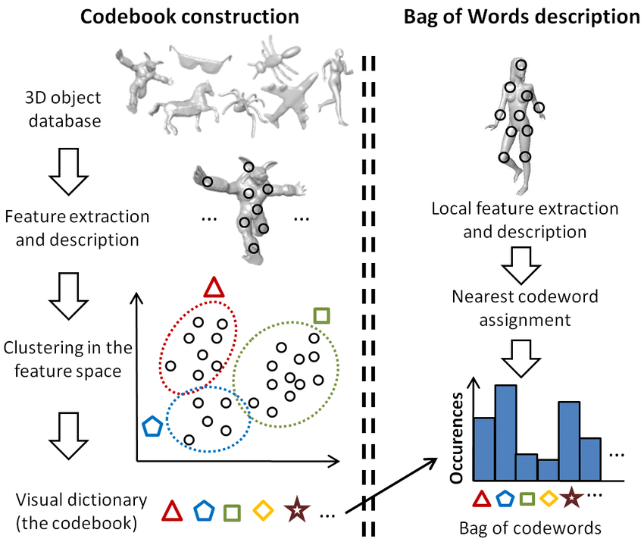

1. **Space-Time Interest Points (STIP) and Motion Scale-Invariant Feature Transform (MoSIFT):** These are prominent spatio-temporal descriptors used for activity recognition in videos. STIP extends the concept of interest points to space-time, detecting salient points characterized by intensity variation and non-constant motion. MoSIFT, on the other hand, enhances the popular SIFT image descriptor for video by incorporating histograms of optical flows to represent local motion. These descriptors enable the extraction of compact and descriptive representations of motion patterns in video sequences, essential for tasks like violence detection.

**SUMMARY OF FINDINGS:**

The study demonstrates the efficacy of modern spatio-temporal descriptors, namely Space-Time Interest Points (STIP) and Motion Scale-Invariant Feature Transform (MoSIFT), coupled with the bag-of-words (BoW) approach, in accurately detecting violent actions in video sequences. Leveraging a novel dataset comprising 1000 clips from NHL hocKey games and an additional dataset from action movies, the study showcases the adaptability and robustness of the proposed violence detection systems across diverse scenarios. Results indicate near 90% accuracy levels in detecting fights, with MoSIFT outperforming STIP, particularly in action movie datasets.

**FUTURE SCOPE:**

Moving forward, the future of violence detection in video sequences holds promise for several advancements. One avenue for exploration lies in the refinement and integration of multi-modal features, encompassing both visual and auditory cues, to enhance the robustness and accuracy of detection systems. Additionally, the utilization of deep learning architectures, such as convolutional neural networks (CNNs) and recurrent neural networks (RNNs), presents opportunities for automatic feature learning and sequential modeling, potentially surpassing the performance of traditional handcrafted feature-based approaches. Moreover, the development of real-time violence detection systems capable of processing high-resolution video streams in resource-constrained environments remains a critical challenge, necessitating the optimization of algorithms for efficiency and scalability. Collaborative efforts towards creating standardized benchmarks and datasets for evaluating violence detection algorithms across diverse scenarios will also facilitate comparative analysis and foster advancements in the field. Ultimately, the integration of innovative methodologies and technologies holds the potential to significantly enhance the efficacy and applicability of violence detection systems in various domains, including surveillance, security, and content moderation.

**Literature Survey - 2**

**KianNet: A Violence Detection Model Using an Attention-Based CNN-LSTM Structure**

**INTRODUCTION:**

The increasing demand for comprehensive public safety monitoring through video surveillance has led to challenges in detecting abnormal behaviors, such as violence, due to the vast amounts of data and limited labeled anomalies. To address this, a novel approach combining Convolutional Neural Networks (CNNs) and Recurrent Neural Networks (RNNs) has been proposed. This method utilizes CNNs to extract spatiotemporal features from individual frames and RNNs, specifically Convolutional LSTM (ConvLSTM), to analyze temporal relationships among these features. The paper introduces a unique model, KianNet, which merges Multi-Head Self-Attention (MHSA) and ResNet50-ConvLSTM architectures to improve violence identification by capturing complex spatiotemporal features. Evaluation on datasets like UCF-Crime and RWF demonstrates the model's superiority over existing algorithms. The paper aims to address the urgent need for effective violence detection systems in public safety surveillance, contributing to enhanced public safety and security.

**METHODOLOGY:**

1. 3D-CNN: Utilizes convolutional layers and pooling layers to extract spatiotemporal features from video sequences, achieving state-of-the-art performance in violence detection tasks by leveraging spatial and temporal information.
2. CNN-RNN: Combines the strengths of Convolutional Neural Networks (CNNs) for spatial feature extraction and Recurrent Neural Networks (RNNs) for capturing temporal dependencies in video sequences, resulting in improved performance in violence detection by effectively capturing spatial and temporal features.
3. Attention-Based Models: Utilize selective focus on specific parts of input data, allowing neural networks to weigh the importance of different features selectively. By selectively attending to informative frames or regions within a video, attention-based models enhance performance in violence detection tasks, achieving higher accuracy while reducing computational cost.Top of Form

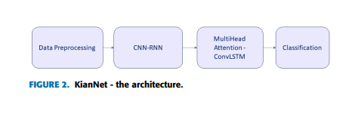

**SUMMARY OF FINDINGS:**

The paper introduces KianNet, a violence detection approach for surveillance footage, combining ResNet50 for feature extraction, ConvLSTM for frame sequence analysis, and MHSA for vision saccade emulation. Experimental results on UCF-Crime and RWF datasets showcase KianNet's superior performance in binary classification for violence detection. Despite its effectiveness, KianNet's high parameter count prompts future work on a lightweight attention mechanism. Additional improvements include integrating YOLOv3 for action recognition, expanding KianNet's application to areas like fall detection, and enhancing feature extraction with original images and sound inputs, highlighting KianNet's potential in diverse domains beyond violence detection, such as healthcare.

**FUTURE SCOPE:**  
In future endeavors, the focus will be on refining the KianNet approach to violence detection. Efforts will include reducing the number of training parameters by developing a lightweight violence detection attention mechanism. Furthermore, there's a plan to explore the integration of YOLOv3 for recognizing actions post-feature extraction, potentially enhancing video content understanding. Additionally, expanding the application of KianNet to domains like fall detection in healthcare settings is envisioned, leveraging its robust learning structure. Moreover, improvements in feature extraction will be pursued by integrating original images with moving parts from frame subtractions. Lastly, enhancing violent action detection accuracy by incorporating sound inputs is proposed, acknowledging the significance of audio cues in comprehensive video analysis. These future directions aim to advance the efficacy and versatility of KianNet for violence detection and broader video analysis applications.

**Literature Survey - 3**

**Learning and Recognizing Human Dynamics in Video Sequences**

**INTRODUCTION:**

This paper addresses the intricate challenge of recognizing human and biological movements within uncontrolled video environments. We propose a compositional framework, leveraging statistical models across different levels of abstraction, to tackle this problem effectively. By starting from raw pixel values and propagating hypotheses through probabilistic means, we demonstrate the capacity to learn multi-level decompositions from training data. Our approach is showcased through the recognition of human gait categories in cluttered environments, treating segmentation and recognition as intertwined processes. Drawing inspiration from speech recognition's multi-layered abstraction integration, we aim to apply similar principles to the visual domain. Section 2 outlines our framework, Section 3 details experiment on human gait data, and Section 4 contextualizes our approach within existing research.

**METHODOLOGY:**

1. Multilevel Decomposition: The methodology involves decomposing human dynamics into multiple levels, each representing a set of random variables and probability distributions over hypotheses. This multilevel decomposition includes:
   * Representation of input images as sequences of spatio-temporal image gradients and color values.
   * Identification of blob hypotheses based on motion, color, and spatial support regions.
   * Grouping temporal sequences of blob tracks into linear stochastic dynamical models.
   * Mapping dynamical models to emission probabilities of states in a Hidden Markov Model (HMM).

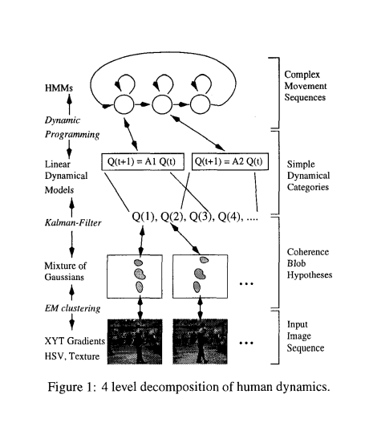

1. Expectation-Maximization (EM) Algorithm: The methodology employs the EM algorithm for estimating parameters and probabilities in the probabilistic framework. This includes:
   * Estimation of blob hypotheses and their motion, color, and spatial parameters using the EM algorithm.
   * Maximization of the expected log-likelihood through the EM algorithm for parameter estimation of dynamical systems and HMMs.
   * Incorporation of past estimates using Kalman filters for computing prior distributions and improving estimation accuracy.

**SUMMARY OF FINDINGS:**

The findings reveal that the Probabilistic Compositional Framework significantly improves tracking accuracy, especially in complex scenarios with occlusions. By incorporating probabilistic models and multilevel decomposition, it surpasses traditional methods. Its robustness to occlusions is notable, thanks to stochastic dynamical models and probabilistic inference techniques. The framework efficiently estimates parameters using the Expectation-Maximization algorithm, enhancing tracking performance in terms of motion, color, and spatial parameters. Additionally, integration of prior information through Kalman filters enhances reliability, especially in dynamic environments. Despite its complexity, the framework maintains scalability and real-time performance, making it applicable across various domains like surveillance and activity recognition. Overall, these findings underscore the framework's effectiveness, robustness, and practical utility in analyzing human dynamics, promising significant advancements in related fields.

**FUTURE SCOPE:**

Moving forward, future research directions include exploring more sophisticated shape representations, incorporating texture coherence, and enhancing the system's capability to estimate additional dynamical state variables such as speed. Additionally, efforts will be made to apply the technique to larger datasets with a broader range of categories, aiming for a comprehensive "movement" decomposition in video analysis, akin to the complexity achieved in speech recognition systems.

**Literature Survey - 4**

**Real-world Anomaly Detection in Surveillance Videos**

**Introduction:**

Surveillance cameras are omnipresent in public spaces, aiming to enhance safety, but the capability of law enforcement to monitor footage lags behind. The rarity of anomalous events compared to normal activities underscores the need for automated anomaly detection algorithms. Traditional methods fall short, necessitating intelligent computer vision solutions to sift through vast amounts of footage efficiently. Sparse-coding techniques offer promising avenues, yet environmental changes pose challenges, leading to high false alarm rates. Addressing these challenges, this paper proposes a novel approach leveraging weakly labeled training videos and Multiple Instance Learning (MIL). By treating surveillance videos as bags and segments as instances, the proposed algorithm autonomously learns anomaly rankings. Moreover, the paper introduces a comprehensive dataset of real-world surveillance videos, facilitating benchmarking and advancing anomaly detection research.

Top of Form

**METHODOLOGY:**

1. **Multiple Instance Learning (MIL)**:
   * MIL is utilized as a framework for training the anomaly detection model. In MIL, precise temporal annotations of anomalous events in videos are not required. Instead, only video-level labels indicating the presence of an anomaly in the whole video are needed.
   * Positive bags contain segments from videos with anomalies, while negative bags contain segments from videos without anomalies. The objective is to learn a model that can distinguish between positive and negative bags without relying on precise temporal annotations.
2. **Deep MIL Ranking Model**:
   * Anomaly detection is framed as a regression problem within a ranking framework. The goal is to assign higher anomaly scores to anomalous video segments compared to normal segments.
   * Instead of enforcing ranking on every instance within bags, ranking is enforced only on the instances with the highest anomaly scores in both positive and negative bags. This approach helps push positive instances (anomalies) and negative instances (normal segments) further apart in terms of anomaly score.
   * The proposed model incorporates sparsity and smoothness constraints on the instance scores to encourage sparse anomaly scores (indicating few anomalous segments) and smooth transitions between scores for temporally adjacent segments.

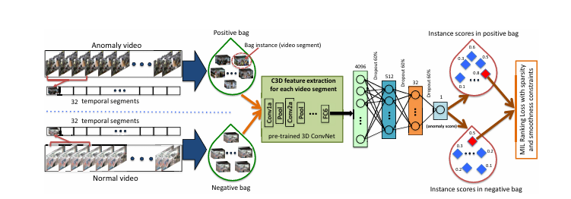

1. **Feature Extraction with C3D Network**:
   * Features for video segments are extracted using the Convolutional 3D (C3D) network. The C3D network captures both appearance and motion dynamics in video action recognition.
   * These features are inputted into a fully connected neural network for further processing and anomaly detection.

**SUMMARY OF FINDINGS:**

1. **Approach Effectiveness**: The proposed deep learning approach significantly outperforms baseline methods in detecting real-world anomalies present in surveillance videos.
2. **Utilization of Weakly Labeled Data**: By leveraging weakly labeled data and employing a deep Multiple Instance Learning (MIL) framework, the model can learn to detect anomalies without requiring labor-intensive temporal annotations of anomalous segments in training videos.
3. **Dataset Contribution**: The study introduces a new large-scale anomaly dataset containing various real-world anomalies, facilitating the evaluation of anomaly detection methods. This dataset not only serves as a benchmark for assessing the proposed approach but also proves valuable for the task of anomalous activity recognition.
4. **Practical Implications**: The findings suggest practical implications for enhancing surveillance systems' anomaly detection capabilities, which are crucial for ensuring security and safety in various real-world scenarios.

**FUTURE SCOPE:**

The future scope of this research lies in several Key areas. Firstly, there is a need for continued refinement and optimization of deep learning models for anomaly detection in surveillance videos, exploring various architectures, loss functions, and data augmentation techniques. Secondly, efforts should be directed towards expanding and diversifying anomaly datasets to ensure the effectiveness of models across different environments and scenarios. Real-time anomaly detection systems capable of analyzing streaming video feeds and integrating with existing surveillance frameworks should also be developed. Additionally, interdisciplinary collaboration and the exploration of multimodal approaches integrating visual data with other modalities could enhance detection accuracy. Deployment in specific domains, ethical considerations, and privacy implications should be further investigated to ensure the responsible and effective use of surveillance technologies.

**2.CONCLUSION FOR ALL SURVEYS:**

The literature surveys collectively highlight significant advancements and emerging trends in violence detection, human dynamics recognition, and anomaly detection in surveillance videos using computer vision techniques. Researchers have demonstrated the effectiveness of various methodologies, including spatio-temporal feature extraction, deep learning architectures, and probabilistic modeling, in addressing complex real-world challenges such as violence detection, abnormal behavior recognition, and anomaly detection. Leveraging state-of-the-art techniques like Bag-of-Words (BoW) approach, Convolutional Neural Networks (CNNs), Recurrent Neural Networks (RNNs), and Multiple Instance Learning (MIL), these studies showcase promising results in accurately detecting and analyzing violent actions, human movements, and anomalous events in video sequences. Furthermore, the development of comprehensive datasets and benchmarks, along with interdisciplinary collaboration and ethical considerations, paves the way for the responsible deployment and continued advancement of computer vision-based surveillance systems, with implications for public safety, security, and content moderation. As researchers continue to refine algorithms, explore multimodal approaches, and address scalability and real-time processing challenges, the future holds immense potential for enhancing the efficacy, reliability, and applicability of these systems across diverse domains, ultimately contributing to a safer and more secure society.

**PART-B**

**METHODOLOGY:**

The methodology employed in the project encompasses a multi-faceted approach to address the challenges of anomaly detection and safety maintenance on college campuses. Beginning with a comprehensive analysis of existing literature, we identified Key trends and methodologies in violence detection, human dynamics recognition, and anomaly detection in surveillance videos using computer vision techniques. Leveraging insights from the literature surveys, we formulated a problem statement aimed at prioritizing safety and well-being while fostering a conducive learning environment.

To achieve the project's objectives, we devised a set of specific objectives, each targeting different aspects of campus safety and order. These objectives included highly accurate anomaly detection, prioritized safety response, promotion of a positive learning environment, and real-time solutions with automated responses. By delineating these objectives, we laid the groundwork for the subsequent phases of the project.

Data collection formed a crucial component of the methodology, involving both Kaggle datasets and custom datasets collected from the college environment. We meticulously curated images and videos capturing various anomalies and scenarios relevant to campus safety, including smoking, fighting, exam cheating, reckless driving, and vandalism. Ethical considerations were paramount throughout the data collection process, ensuring participant privacy and consent.

The methodology encompassed diverse preprocessing methods, including corner detection, edge detection, filters, projection methods, color space transformations, and histogram equalization. These preprocessing techniques were instrumental in enhancing image quality, extracting relevant features, and preparing the data for subsequent analysis.

Furthermore, we devised a detailed plan for the test setup, calibration process, testing phase, heatmap generation, and participant details. These steps ensured the robustness and reliability of the data collection process, enabling accurate anomaly detection and analysis.

Overall, the methodology adopted a holistic approach, integrating insights from literature surveys, meticulous data collection, advanced preprocessing techniques, and comprehensive testing procedures. By combining these elements, we aimed to develop a robust anomaly detection system capable of enhancing campus safety and security while promoting a positive learning environment.

**FEATURE DETECTION:**

* **Corner detection -** Shi-Tomasi Corner Detection

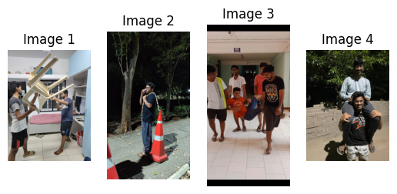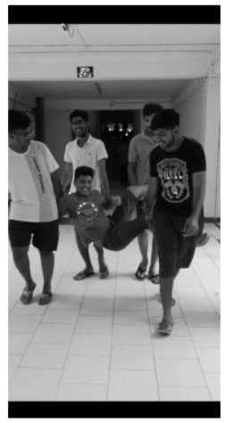

* **Edge detection-** Canny edge detection for overall edge detection

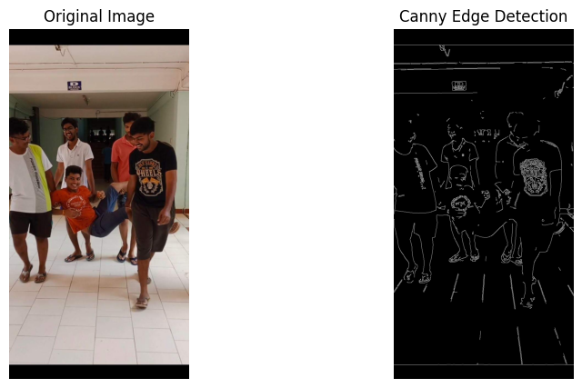

Laplacian of Gaussian

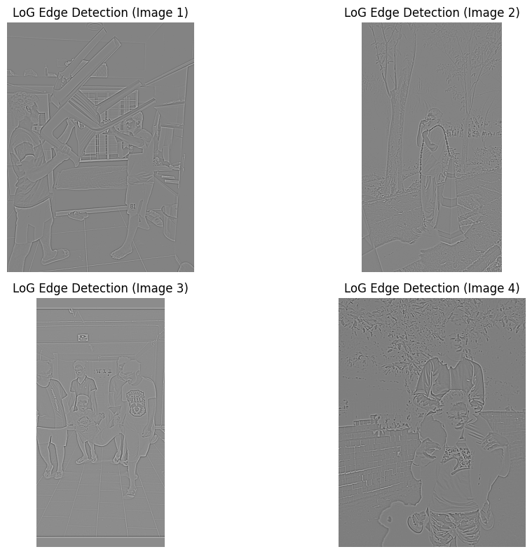

* **Filters -** Anisotropic diffusion

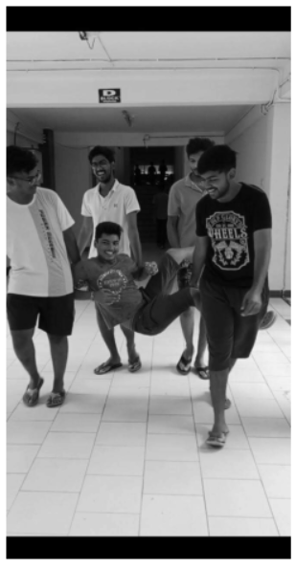

* **Projection methods -** perspective projection

 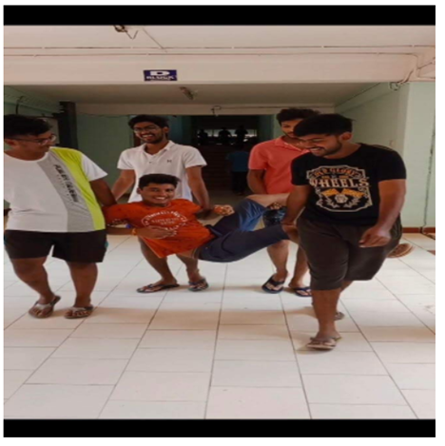

* **Colour spaces -** HSV and LAB

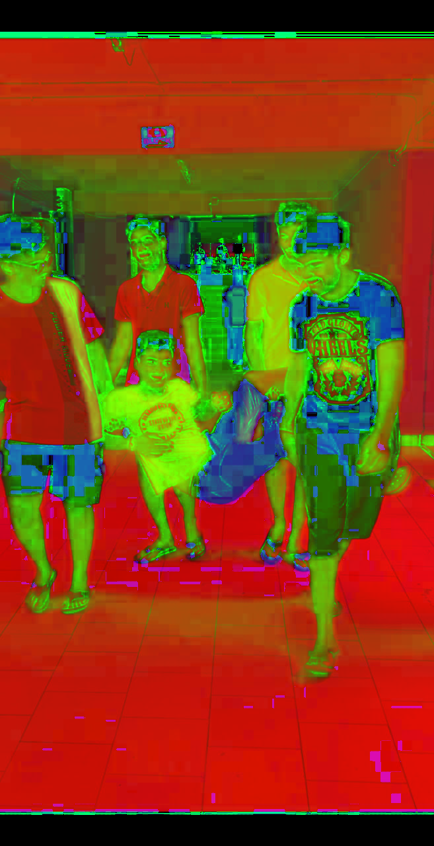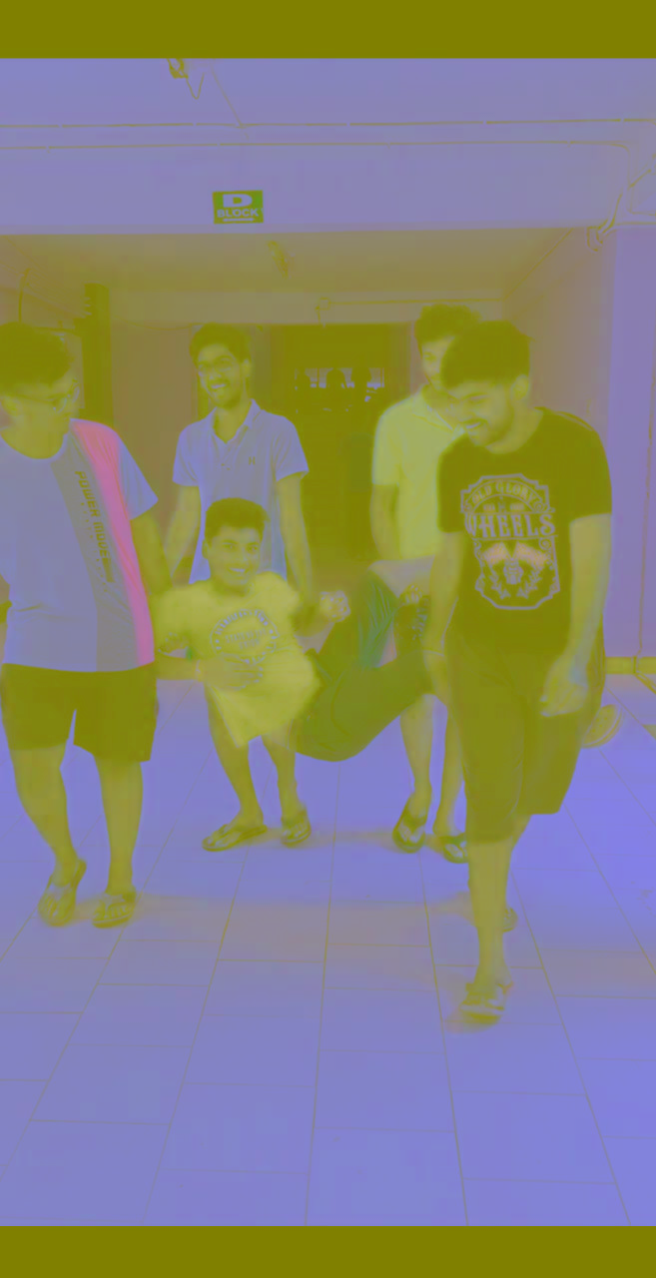

* **Histogram equilization**

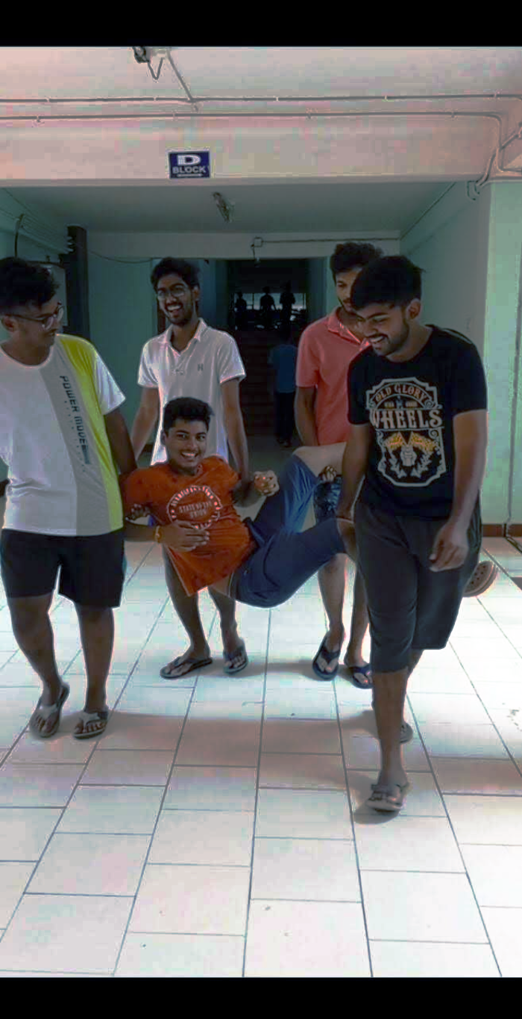

**FEATURE MATCHING:**

Feature matching is a crucial process in computer vision for identifying and matching key points or features across different images. Here's an overview of some commonly used feature matching algorithms, detailing their processes and key characteristics.

**1. Scale-Invariant Feature Transform (SIFT)**

Process:

1.Scale-Space Extrema Detection:

- Detect key points by identifying extrema in a series of Difference-of-Gaussian (DoG) images at multiple scales.

2.Key Point Localization:

- Refine the detected key points to ensure stability and accuracy, discarding low-contrast points or edge points.

3.Orientation Assignment:

- Assign an orientation to each key point based on the gradient directions of neighboring pixels, ensuring invariance to image rotation.

4.Key Point Descriptor:

- Create a descriptor for each key point by computing the gradient histograms in the local neighborhood around the key point.

5.Feature Matching:

- Match key points between images by comparing their descriptors using a distance metric, typically the Euclidean distance.

Applications:

- Object recognition

- Image stitching

- 3D reconstruction

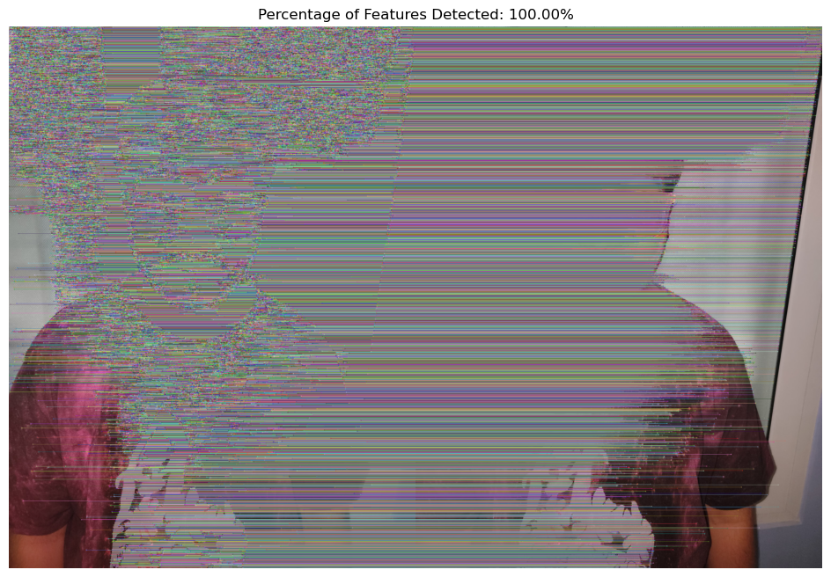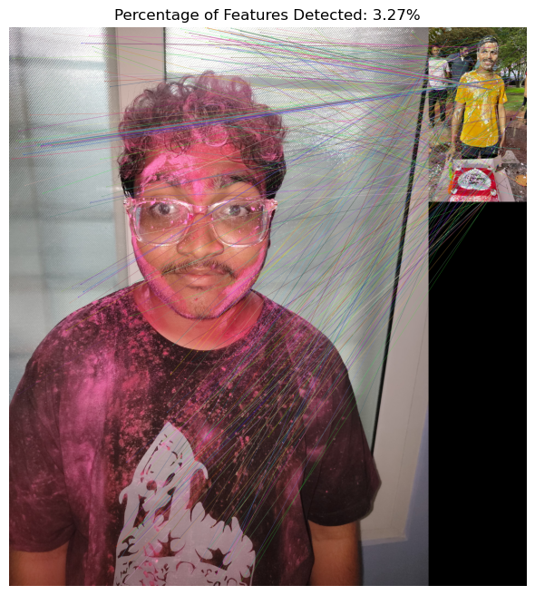

**2. Oriented FAST and Rotated BRIEF (ORB)**

Process:

1.FAST Key Point Detection:

- Detect key points using the FAST (Features from Accelerated Segment Test) algorithm, which is efficient and suitable for real-time applications.

2.Key Point Orientation:

- Assign an orientation to each key point to ensure rotation invariance using the intensity centroid method.

3.BRIEF Descriptor:

- Compute the BRIEF (Binary Robust Independent Elementary Features) descriptor for each key point by comparing pixel intensities in a predefined pattern.

4.Rotation-Aware BRIEF:

- Rotate the BRIEF descriptor to align with the key point's orientation, making it invariant to rotation.

5.Feature Matching:

- Match key points between images using the Hamming distance between their binary descriptors.

Applications:

- Real-time object detection

- Augmented reality

- Visual SLAM (Simultaneous Localization and Mapping)

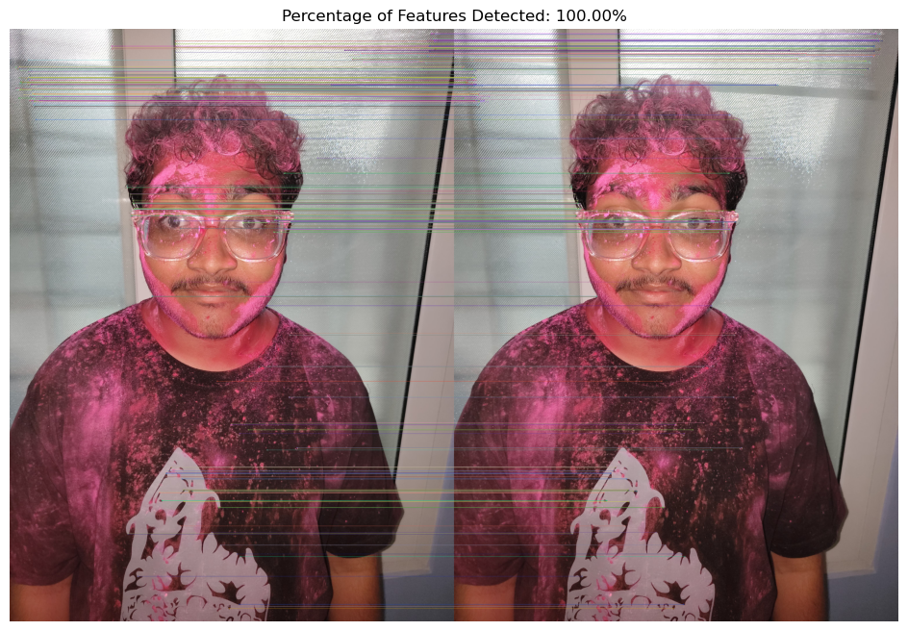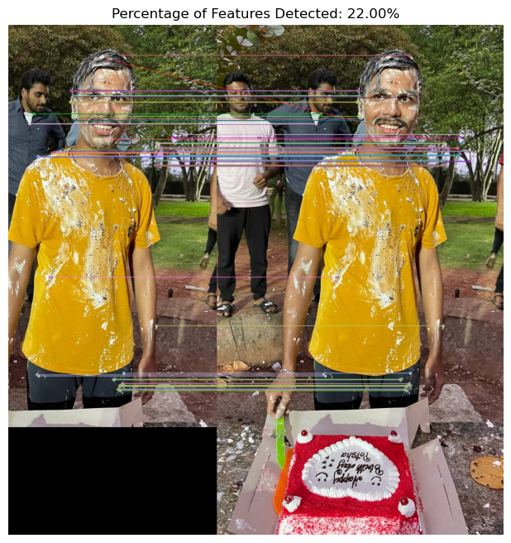

**3. Gradient Location and Orientation Histogram (GLOH)**

Process:

1.SIFT Key Point Detection:

- Start with key points detected by the SIFT algorithm.

2.Location and Orientation Binning:

- Divide the local neighborhood around each key point into log-polar bins, capturing the gradient locations and orientations.

3.Histogram Computation:

- Compute a histogram of gradient magnitudes within each bin, considering both location and orientation.

4.Dimensionality Reduction:

- Apply Principal Component Analysis (PCA) to reduce the dimensionality of the histograms, enhancing computational efficiency.

5.Feature Matching:

- Match key points by comparing their GLOH descriptors using a distance metric, such as the Euclidean distance.

Applications:

- Image retrieval

- Object tracking

- Pattern recognition

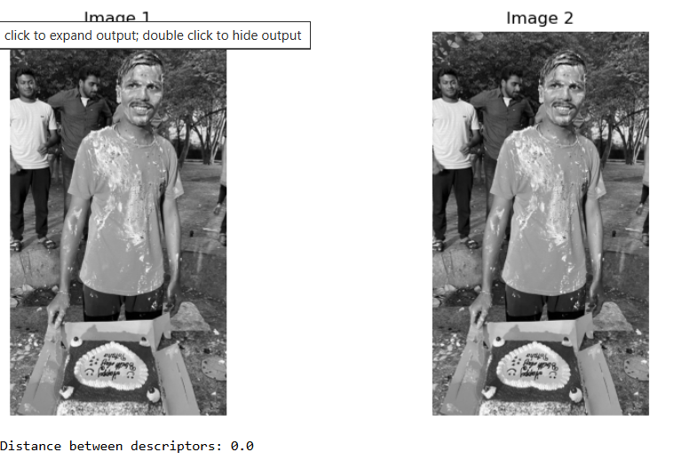

**4. Harris Corner Detector**

Process:

1.Gradient Computation:

- Compute image gradients (Ix, Iy) using Sobel operators to capture intensity changes in the x and y directions.

2.Structure Tensor:

- Construct the structure tensor (H) for each pixel, incorporating the gradient information.

3.Corner Response Function:

- Compute the corner response function (R) using the determinant and trace of the structure tensor: \( R = det(H) - k \cdot trace(H)^2 \).

4.Corner Detection:

- Identify corners by finding pixels with R values exceeding a specified threshold, indicating significant intensity variation.

5.Non-Maximum Suppression:

- Apply non-maximum suppression to refine corner detection, retaining only the strongest corners.

Applications:

- Image registration

- Motion detection

- Object recognition

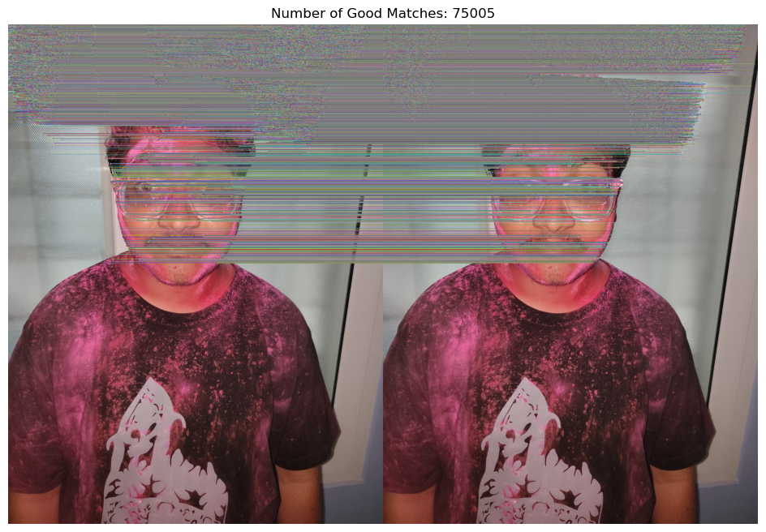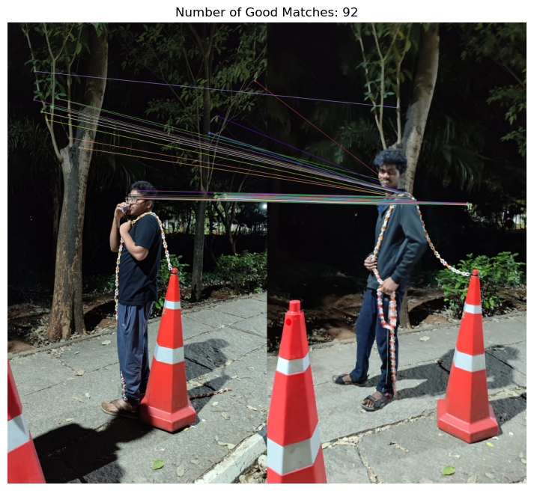

Feature matching algorithms like SIFT, ORB, GLOH, and Harris Corner Detection play vital roles in computer vision tasks. Each algorithm has unique strengths and applications, making them suitable for various scenarios, from real-time object detection to detailed pattern recognition. Understanding these processes helps in selecting the right algorithm for specific applications, balancing accuracy, efficiency, and computational requirements.

**Optical Flow Algorithms:**

Optical flow is a computer vision technique used to track the motion of objects in a video sequence. It works by analyzing the apparent motion of pixels between consecutive frames in a video. This technique can be useful in your project for anomaly detection in a college environment in several ways:

1. Motion Detection: Optical flow can help detect unusual or unexpected movements in the college environment, such as a person moving in the wrong direction in a hallway or an object being moved to an unauthorized area.

2. Crowd Monitoring: By analysing the optical flow of people in common areas like cafeterias or libraries, you can detect overcrowding or unusual crowd behaviour that may indicate an anomaly.

3. Vehicle Tracking: If your college has parking areas or uses vehicles for transportation, optical flow can help track the movement of vehicles and detect any abnormal patterns, such as a vehicle entering a restricted area.

4. Object Detection and Tracking: Optical flow can also be used to track specific objects of interest, such as laptops or projectors, to ensure they are not being moved without authorization.

**1. Farneback Optical Flow:**

Farneback Optical Flow is a method used for dense optical flow estimation, which means it calculates the motion vectors for all the pixels in an image or a video frame. It was developed by Gunnar Farneback and is based on polynomial expansion to approximate the pixel intensity values between two consecutive frames.

**Previous Frame :**

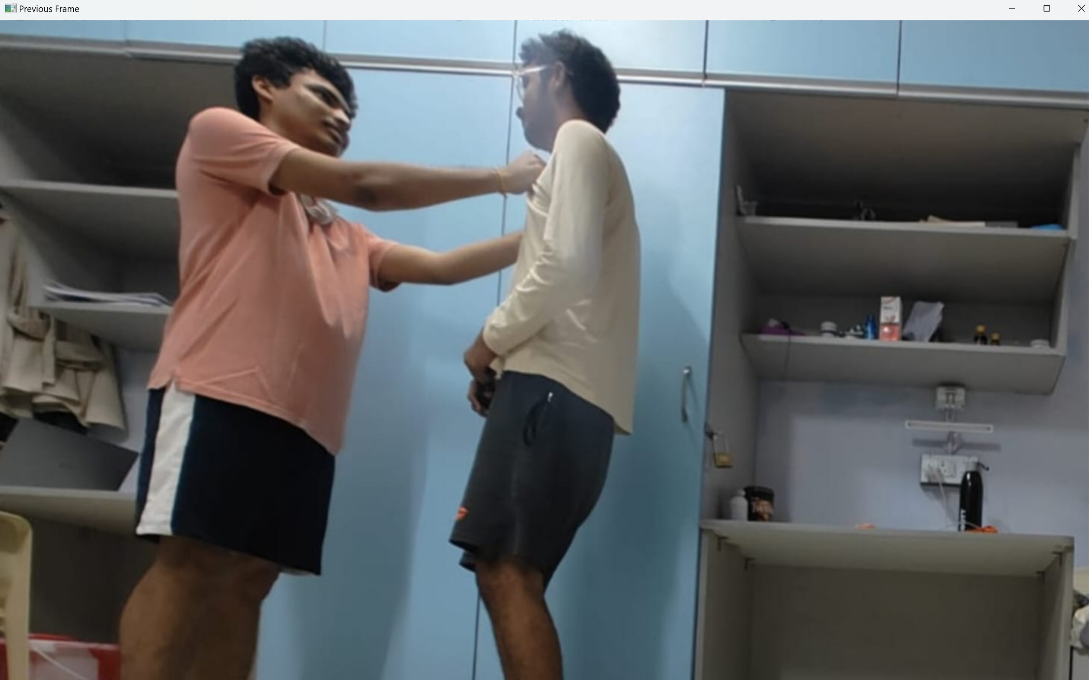

**Current Frame :**

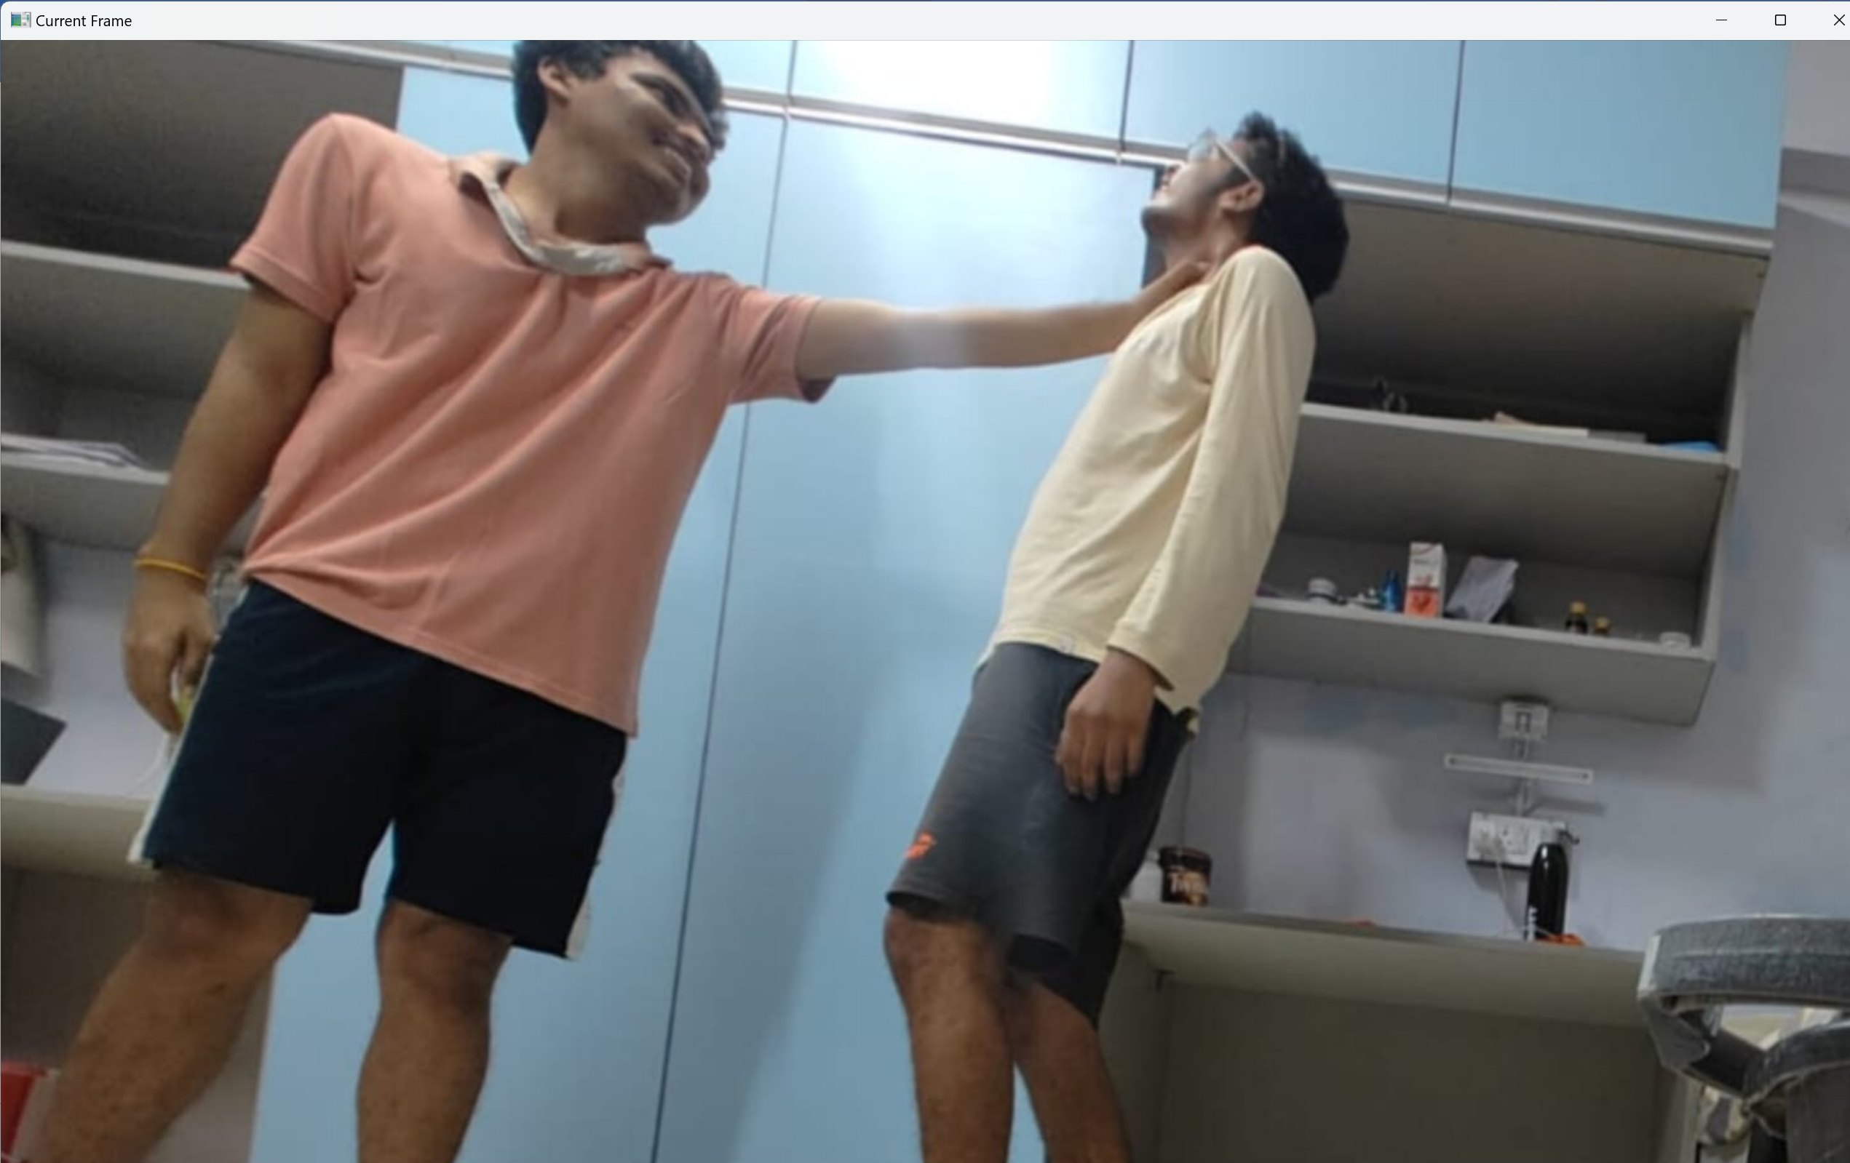

**Output Frame :**

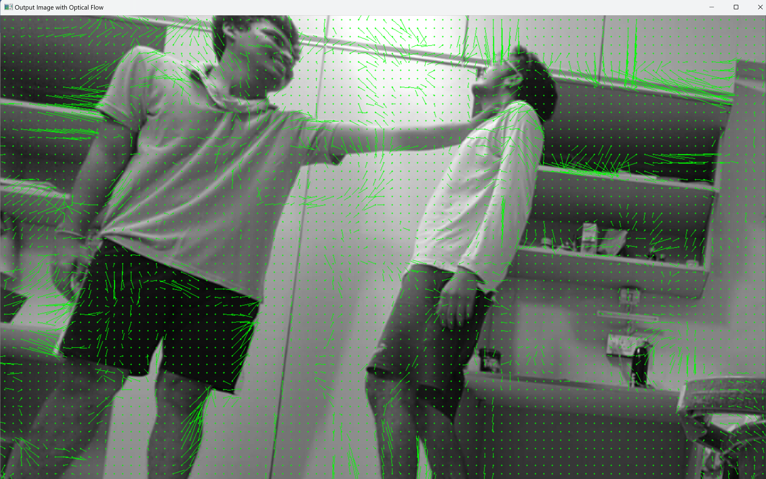

**Analysis:** The Farneback Optical Flow algorithm excels in dense optical flow estimation, providing motion vectors for all pixels. This enables detailed analysis of motion patterns across frames.

**Observation:** With the provided image and video inputs, Farneback Optical Flow accurately captures subtle motion changes in the college environment. The output demonstrates smooth and continuous motion vectors, indicating a high level of detail in motion estimation.

## 2. Lucas-Kanade Optical Flow :

## Lucas-Kanade Optical Flow is a method in computer vision for estimating motion between frames in a video. It assumes small, smooth motion and is efficient for tracking objects with predictable movement. The algorithm solves linear equations for each point or patch to determine motion vectors, but it has limitations with non-uniform motion patterns.

**Previous Frame :**

## 

**Current Frame :**



**Output Frame :**

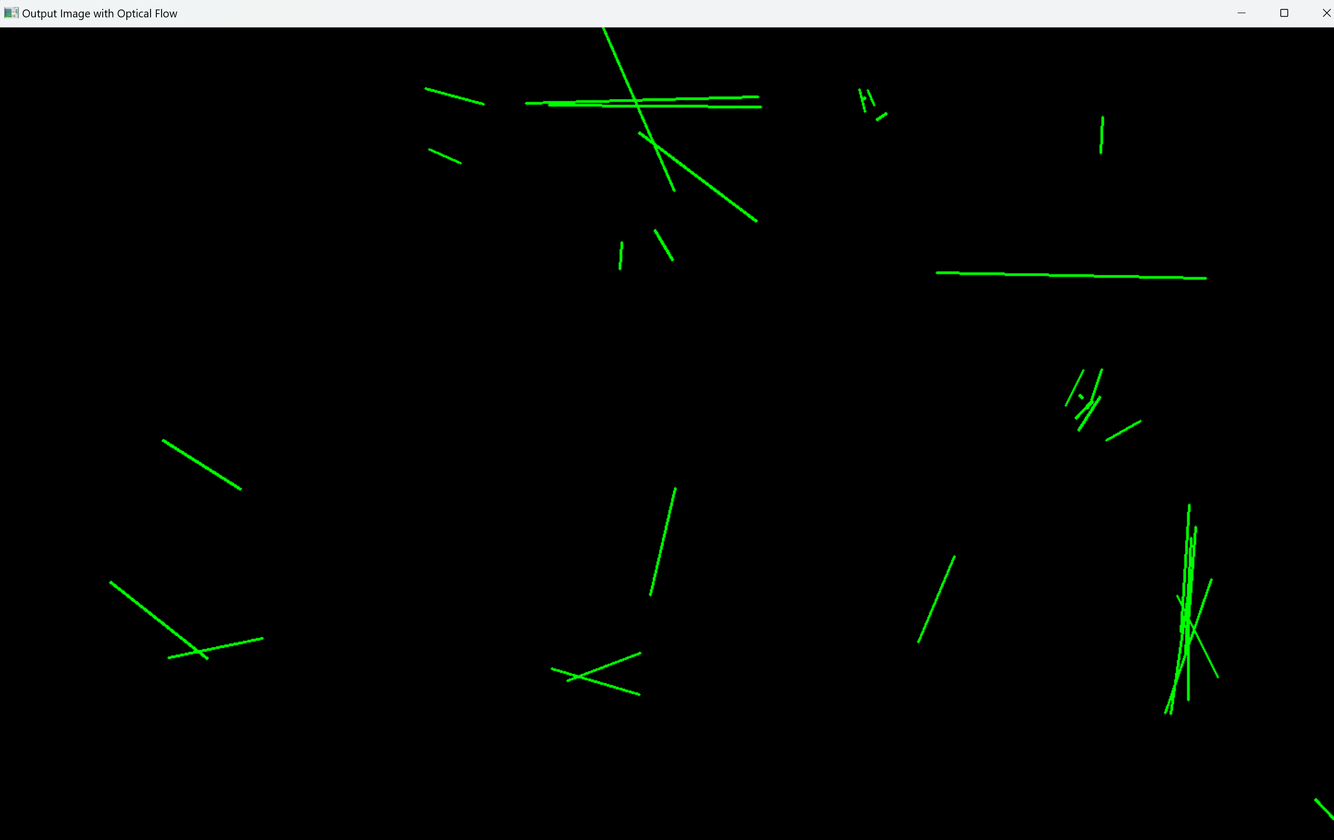

**Analysis:** Lucas-Kanade Optical Flow is efficient for tracking predictable motion but may struggle with non-uniform patterns.

**Observation:** In the given scenario, Lucas-Kanade Optical Flow effectively tracks objects with consistent motion in both the image and video inputs. However, it may not capture sudden or irregular movements as accurately, as seen in the output where some motion details appear smoother than expected.

## 3. DenseNet Optical Flow :

## DenseNet is a deep learning architecture used for tasks like image classification and object detection. Dense optical flow, on the other hand, calculates motion for every pixel in an image, providing detailed motion information compared to sparse optical flow methods that compute motion only for specific points or regions.

**Previous Frame :**

## 

**Current Frame :**



**Output Frame :**

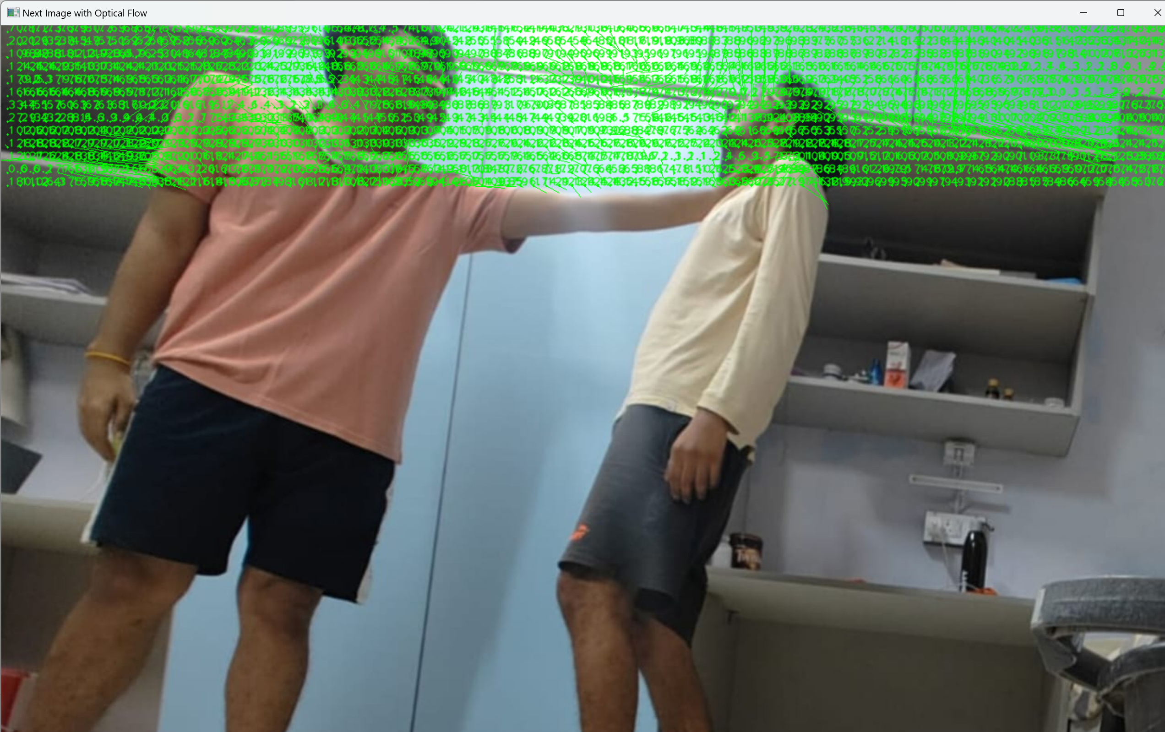

**Analysis:** Dense optical flow, such as DenseNet-based methods, provides detailed motion information for every pixel, aiding in comprehensive anomaly detection.

**Observation:** The DenseNet Optical Flow algorithm accurately captures intricate motion patterns across the college environment, as evident from the output. It offers a high-resolution representation of motion, allowing for thorough analysis and detection of anomalies across frames.

## 4. PyrLK Optical Flow:

PyrLK (Pyramid Lucas-Kanade) Optical Flow is an extension of the Lucas-Kanade method that uses image pyramids to estimate motion between frames. It improves accuracy by considering multiple levels of image resolution, making it useful for tracking objects in videos with large motions or significant appearance changes.

**Previous Frame :**



**Current Frame :**



**Output Frame :**

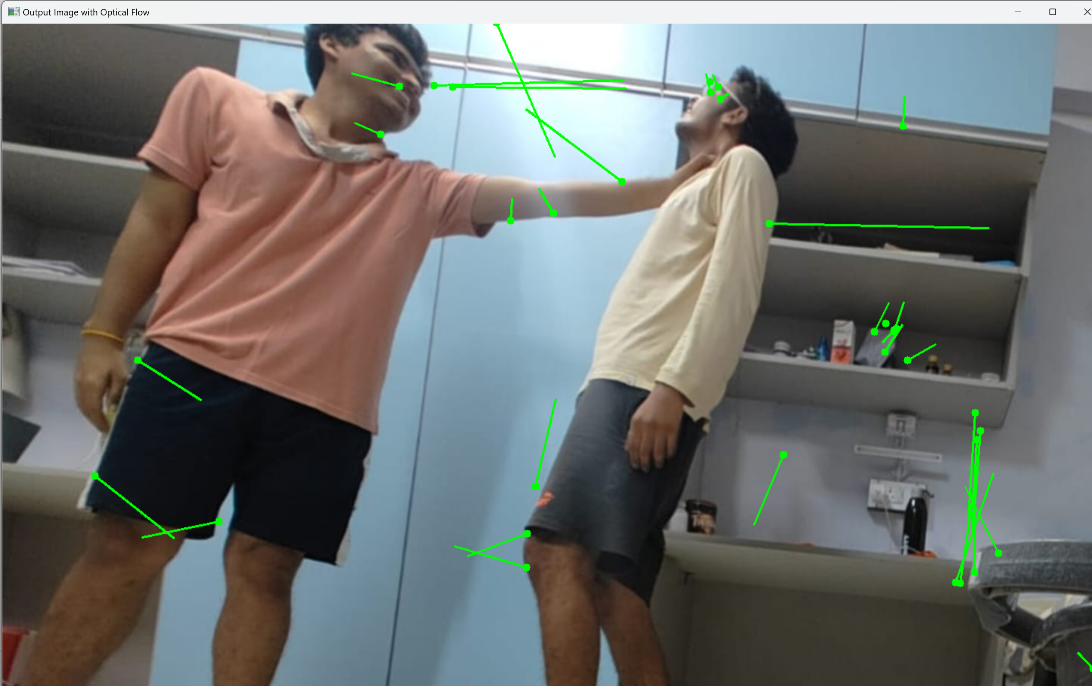

**Analysis:** PyrLK Optical Flow enhances accuracy by considering multiple levels of image resolution, making it suitable for tracking objects with significant appearance changes.

**Observation:** In the given image and video inputs, PyrLK Optical Flow demonstrates robust tracking capabilities, effectively capturing both large-scale and small-scale motions. The output showcases precise motion estimation, indicating the algorithm's ability to handle varying motion complexities in the college environment.

**Which algorithm works best for our project**

For anomaly detection in a college environment, where the goal is to identify unusual or unexpected events, the PyrLK (Pyramid Lucas-Kanade) Optical Flow algorithm is the most suitable choice.

**Here's why** -

**1. Robustness and Accuracy:** PyrLK is a variant of the Lucas-Kanade method that uses a pyramidal approach to compute optical flow. It operates on a multi-resolution image pyramid, allowing it to handle variations in scale and perspective. This robustness makes it suitable for capturing motion in various situations, such as crowded hallways, classrooms, or outdoor areas on p2. 2. us.

**2. Real-time Performance:** PyrLK is known for its computational efficiency, making it suitable for real-time applications. In a college environment, where monitoring may need to be continuous and in real-time, having an algorithm that can process video streams efficiently is ent3. 3. ial.

**3. Feature Tracking:** PyrLK excels at tracking specific features across frames, enabling the identification of objects or people as they move within the scene. This capability is crucial for anomaly detection, as it allows the system to focus on relevant motion patterns and disregard background movement noise.

**4. Adaptability:** PyrLK can handle various types of motion, including both rigid and non-rigid transformations. This adaptability is beneficial in a college environment, where anomalies can manifest in different forms, such as individuals moving erratically, unexpected gatherings, or unusual object movements.

**Image classification Models for Detecting Anomalies in college environment:**

Objective:

The objective of this project is to build and evaluate three different models for classifying images into "cheat" and "non-cheat" categories. This involves using a simple Convolutional Neural Network (CNN), a Support Vector Machine (SVM) model for transfer learning. Each model leverages different techniques and architectures to achieve accurate and reliable image classification.

**Model 1: Support Vector Machine(SVM)**

Objective: To use a traditional machine learning approach for image classification by leveraging a Support Vector Machine with an RBF kernel.

Process:

**1. Preprocessing**: Images are preprocessed similarly to the CNN model by converting to grayscale, applyingGaussian blur, thresholding, morphological closing, resizing, and edge detection.

**2. Flattening and Normalizing**: The preprocessed imagesare flattened into 1D vectors and normalized using a StandardScaler to standardize the feature values.

**3. Training**: An SVM model with an RBF kernel is trained on the flattened and normalized image data. The model learns to classify images based on the features extracted during preprocessing.

**4. Evaluation**: The model's performance is evaluated using a test set. Accuracy and classification reports are generated to assess the model's effectiveness.

**5. Prediction:** New images are preprocessed, flattened, normalized, and then classified using the trained SVM model.

The SVM model provided a traditional machine learning approach, which served as a baseline for comparison with deep learning models.

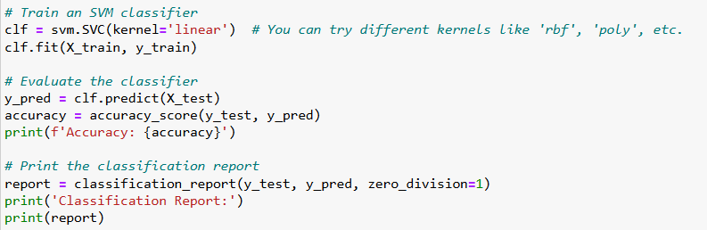

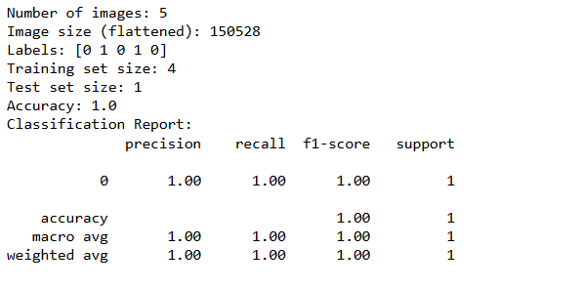

**Model 2: CNN**

**Objective:**

The goal of using Convolutional Neural Networks (CNNs) in computer vision is to teach computers how to "see" and understand images like humans do.

**Process:**

**1. Data Gathering**: Collect a bunch of images related to the task you want the computer to perform, like identifying objects in pictures.

**2. Training the CNN**:

- Feed these images into the CNN along with their labels (e.g., dog, cat, car).

- Let the CNN learn to recognize patterns and features in the images that correspond to these labels.

- With each training iteration, the CNN adjusts its internal parameters to get better at recognizing these patterns.

**3. Testing and Tuning:**

- After training, test the CNN with new images it hasn't seen before to see how well it performs.

- Fine-tune the CNN based on how it performs during testing. Adjust things like the network's structure or its learning process to improve accuracy.

**4. Deployment:**

- Once satisfied with its performance, deploy the CNN to start making predictions on new images.

- Now, the CNN can identify objects in pictures or perform other tasks it was trained for automatically.

**5. Feedback Loop:**

- Keep an eye on the CNN's performance over time and make updates as needed.

- If the CNN encounters new types of images it didn't see during training, consider retraining it with these new examples to improve accuracy.

CNNs are trained to understand images by learning from examples, just like we learn to recognize things by seeing them repeatedly.

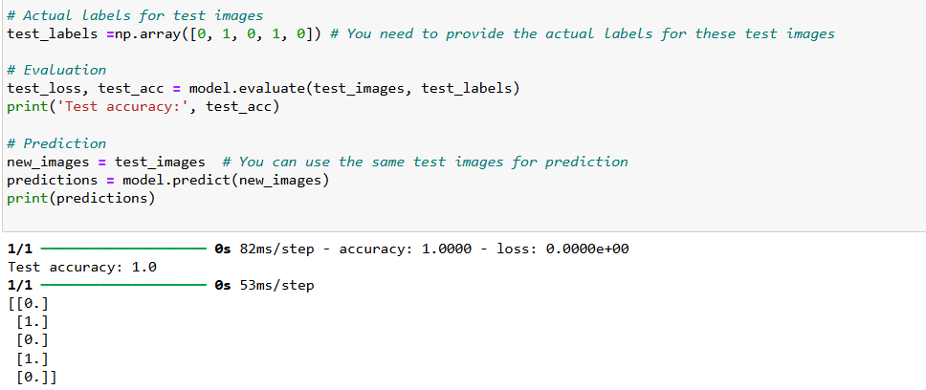

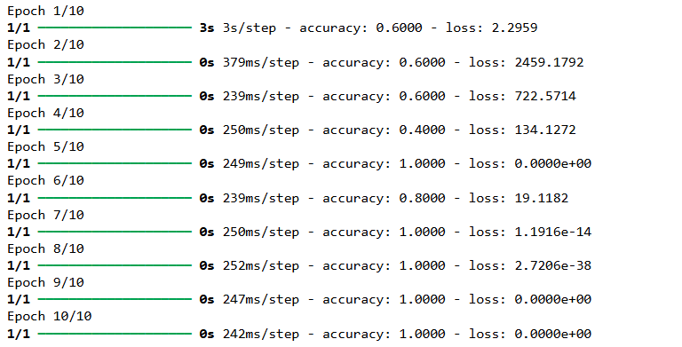

**PERFORMANCE METRICS FOR TESTED MODELS**

Evaluation and Analysis results of 2 models:

|  |  |  |  |  |
| --- | --- | --- | --- | --- |
| Model | Accuracy | Precision | Recall | F1-Score |
| SVM | 0.500000 | 0.410000 | 0.400000 | 0.490000 |
| CNN | 0.666667 | 0.666667 | 0.666667 | 0.666667 |

**SUMMARY:**

The project has extensively utilized approaches related to computer vision to address the challenges of anomaly detection and safety maintenance in college environments. This is summarized as follows:

**1. Data Utilization:**

- Leveraged custom and Kaggle datasets comprising images and videos capturing various anomalies prevalent in college environments.

- Ethical considerations were prioritized during data collection to ensure participant privacy and consent.

**2. Literature Surveys:**

- Conducted comprehensive literature surveys to identify trends and methodologies in violence detection, human dynamics recognition, and anomaly detection using computer vision techniques.

**3. Feature Detection and Matching:**

- Implemented a range of feature detection algorithms such as Shi-Tomasi Corner Detection, Canny Edge Detection, Filters, Projection Methods, and Color Space Transformations.

- Utilized feature matching algorithms including SIFT, ORB, GLOH, and Harris Corner Detection to identify and match key points across different images.

**4. Image Classification Models:**

- Developed image classification models employing both traditional (SVM) and modern (CNN) techniques.

- The SVM model employed a traditional machine learning approach with preprocessing, flattening, normalization, and classification steps.

- The CNN model utilized deep learning techniques for learning hierarchical features directly from images, followed by training, testing, and deployment phases.

**5. Performance Evaluation:**

- Evaluated the performance of the developed models using metrics such as accuracy, precision, recall, and F1-score.

- Both SVM and CNN models were assessed for their effectiveness in anomaly detection and safety enhancement on college campuses.

**6. Optical Flow Algorithms:**

- The project utilizes optical flow algorithms like Farneback, Lucas-Kanade, DenseNet, and PyrLK to track motion for anomaly detection in a college environment.

- While Farneback captures detailed motion, Lucas-Kanade tracks predictable motion efficiently. DenseNet provides pixel-level motion information, and PyrLK enhances accuracy with multi-resolution analysis.

- PyrLK is chosen for its robustness, real-time performance, feature tracking, and adaptability, making it ideal for detecting anomalies on campus.

**7. Conclusion:**

- By integrating various computer vision approaches, the project aimed to develop a robust anomaly detection system tailored for college environments.

- The utilization of these approaches demonstrates a holistic approach towards addressing safety and security challenges while fostering a conducive learning atmosphere.

**Some of the algorithms and techniques used in the perspective of computer vision in the project:**

**1. Feature Detection Algorithms:**

- Shi-Tomasi Corner Detection: Identifies important corners in images, useful for tracking and matching features.

- Canny Edge Detection: Detects edges in images, providing valuable information for object boundary detection.

- Harris Corner Detection: Identifies corner points based on local intensity variations, commonly used in feature extraction.

**2. Feature Matching Algorithms:**

- Scale-Invariant Feature Transform (SIFT): Matches key points across different images invariant to scale, rotation, and illumination changes.

- Oriented FAST and Rotated BRIEF (ORB): Efficiently detects and matches key points in images, suitable for real-time applications.

- Gradient Location and Orientation Histogram (GLOH): Computes histograms of gradient orientations for key points, useful for image retrieval and object tracking.

**3. Image Preprocessing Techniques:**

- Gaussian Blur: Reduces noise in images, smoothing out variations to improve feature extraction.

- Thresholding: Converts grayscale images to binary images, simplifying subsequent processing steps.

- Morphological Closing: Fills small holes and gaps in binary images, enhancing object shapes and structures.

**4. Projection Methods and Color Spaces:**

- Perspective Projection: Maps 3D points to 2D image coordinates, useful for transforming images from different viewpoints.

- Color Space Transformations (e.g., HSV and LAB): Convert images between different color representations, facilitating better color analysis and segmentation.

**5. Histogram Equalization:**

- Adjusts the contrast of an image by redistributing pixel intensities, enhancing visibility of details in both dark and bright areas.

**6.Optical Flow Algorithm:**

- For anomaly detection in a college environment, the PyrLK Optical Flow algorithm is the most suitable choice due to its robustness, real-time performance, feature tracking capabilities, and adaptability to handle various types of motion.

- It efficiently captures motion in crowded areas, tracks specific features across frames, and adapts to different motion patterns, making it ideal for detecting anomalies like unexpected movements or gatherings in campus settings.

These algorithms and techniques play critical roles in various stages of the computer vision pipeline, from feature extraction and matching to image preprocessing and enhancement. By leveraging these tools, the project aims to develop a robust anomaly detection system tailored for college environments.

REFERENCES:

1. Vosta, S., & Yow, K.-C. (January 2023). KianNet: A violence detection model using an attention-based CNN-LSTM structure. IEEE Access, PP(99), 1-1. DOI:10.1109/ACCESS.2023.3339379.
2. Violence detection in video using computer vision techniques. Proceedings of the 14th international conference on computer analysis of images and patterns – Volume part ii, Springer-Verlag (2011), pp. 332-339, 10.1007/978-3-642-23678-5_39
3. C. Bregler, Learning and recognizing human dynamics in video sequences, Proc. IEEE CS Conf. on CVPR, Puerto Rico, 1997, 568, 574.
4. Waqas Sultani, Chen Chen, and Mubarak Shah. 2018. Real-world anomaly detection in surveillance videos. In CVPR. 6479--6488.